**PROPOSED SOLUTION & SYSTEM ARCHITECTURE**

**SYSTEM ARCHITECTURE**

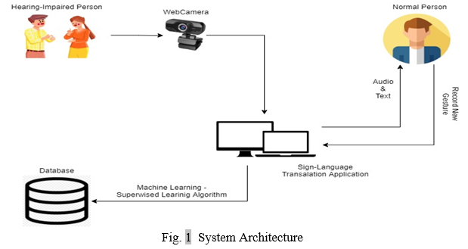

Initially, the images for individual letters and phrases are collected through web camera to build the training model. The model is trained in Google Teachable Machine using the images collected from us via web camera. This model is then embedded in our project which will be used to recognize the gestures given by user. The supervised learning algorithm used here is called Convolutional Neural Network.

**PROPOSED SOLUTION**

Our project is dedicated to empowering individuals with hearing impairments by facilitating their communication with others. We achieve this by translating their sign language and gestures into standard text. These gestures are seamlessly captured via a webcam, guided by state-of-the-art computer vision technology.

To start, we initiate the training process for our model using images acquired through the Google Teachable Machine platform, powered by the Keras framework. The model's accuracy is achieved through the utilization of a Convolutional Neural Network (CNN). This serves as the foundation for our model's ability to predict text based on the captured gestures.

By harnessing the capabilities of machine learning, our model becomes not only highly efficient but also remarkably accurate in predicting the corresponding texts, enhancing the overall communication experience for those with hearing impairments.